**Android UI Design**

1. **UI Design Patterns**
2. Dashboard – Home screen
3. Action Bar – Replaces title bar, for easy navigation
4. Search Bar – Self-explanatory
5. Quick Actions – Popup action bar that doesn’t take up the full screen
6. Companion Widget – For the Android Homepage
   1. **Dashboard**

What the Dashboard should contain:

* Highlight what’s new
* 3 – 6 most important choices

How the Dashboard should be organised

* Features: If you need different entry points for different things
* Categories: If your app is content-focused
* Account: If your app is productivity-focused

Other possible features of the Dashboard:

* Dynamic background
* Real-time updates

Some Dashboard possibilities:

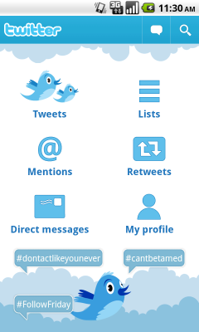 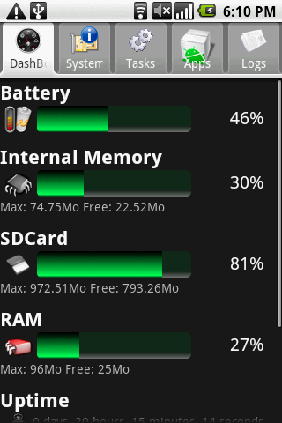

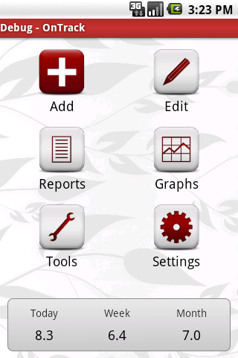 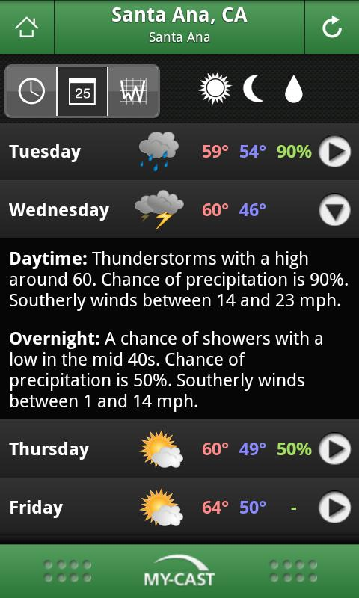

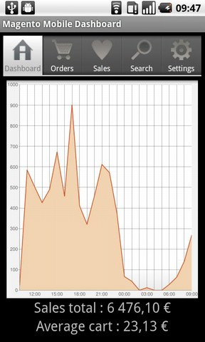

* 1. **Action Bar**

Replaces title bar, at the top of the screen.

Used for navigation and frequently used operations

e.g. Search, Refresh

In our app, should use tabs because we need to flip through distinct

* 1. **Search Bar**

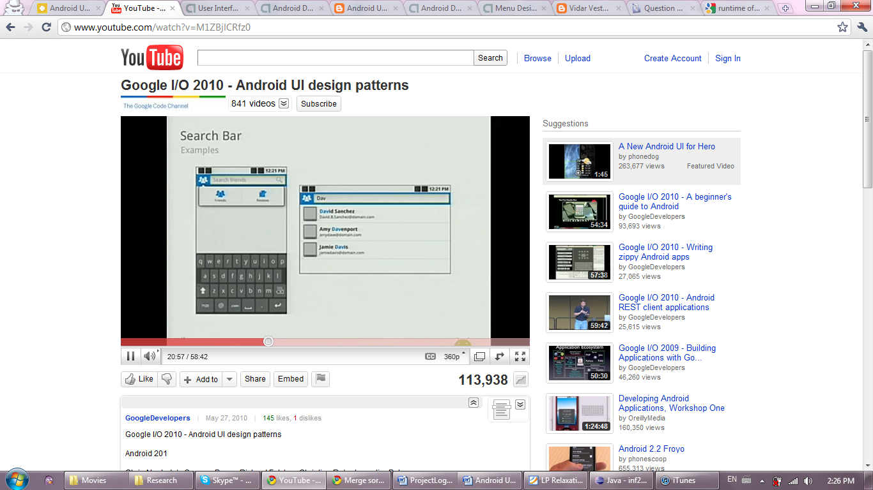

* 1. **Quick Actions**

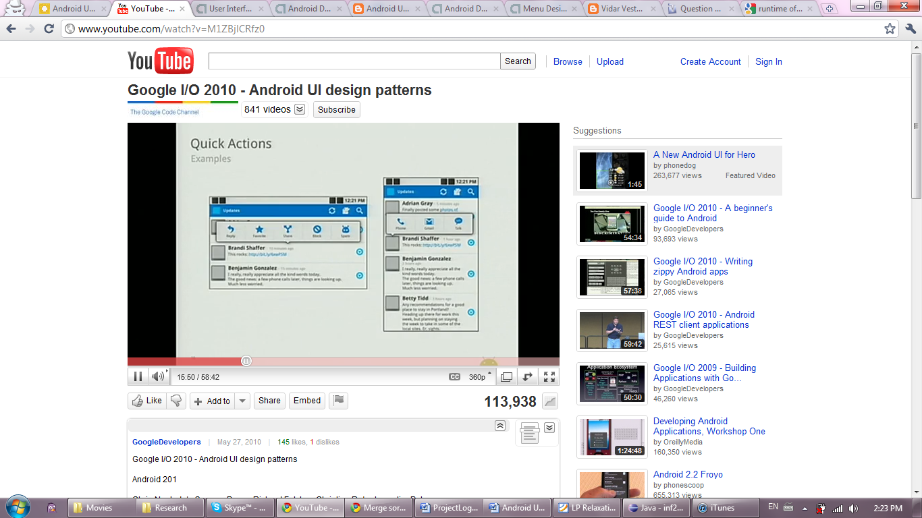

* FAST (most important feature)
  + For new users
  + For better users that need shortcuts
  1. **Companion Widget**

Widget for the main Android screen

Out of CS141 app scope :D

1. **Building a Good UI**

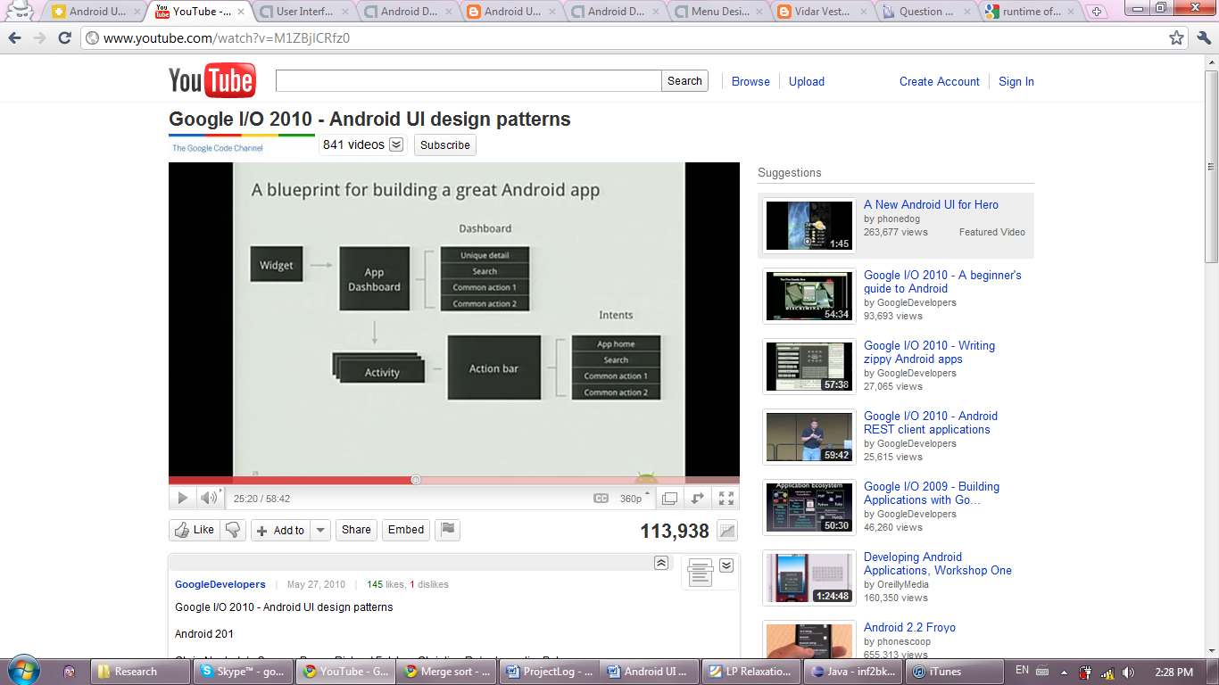

Consider different screen sizes:

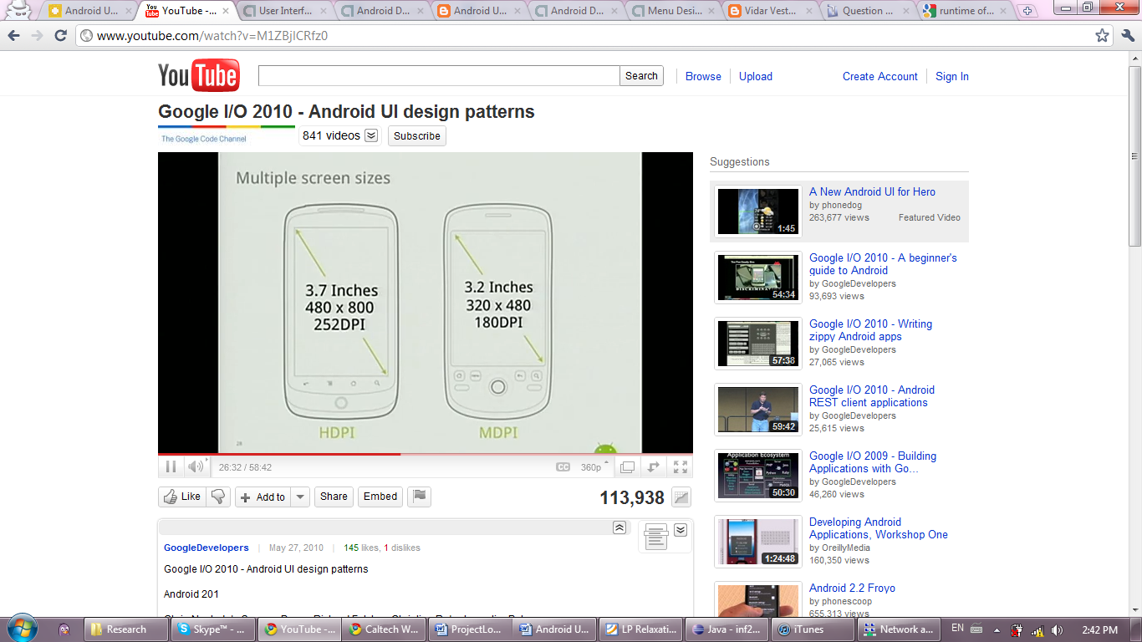

Pixel density – To keep assets roughly the same size

Auto-scales assets

Icon Specifications

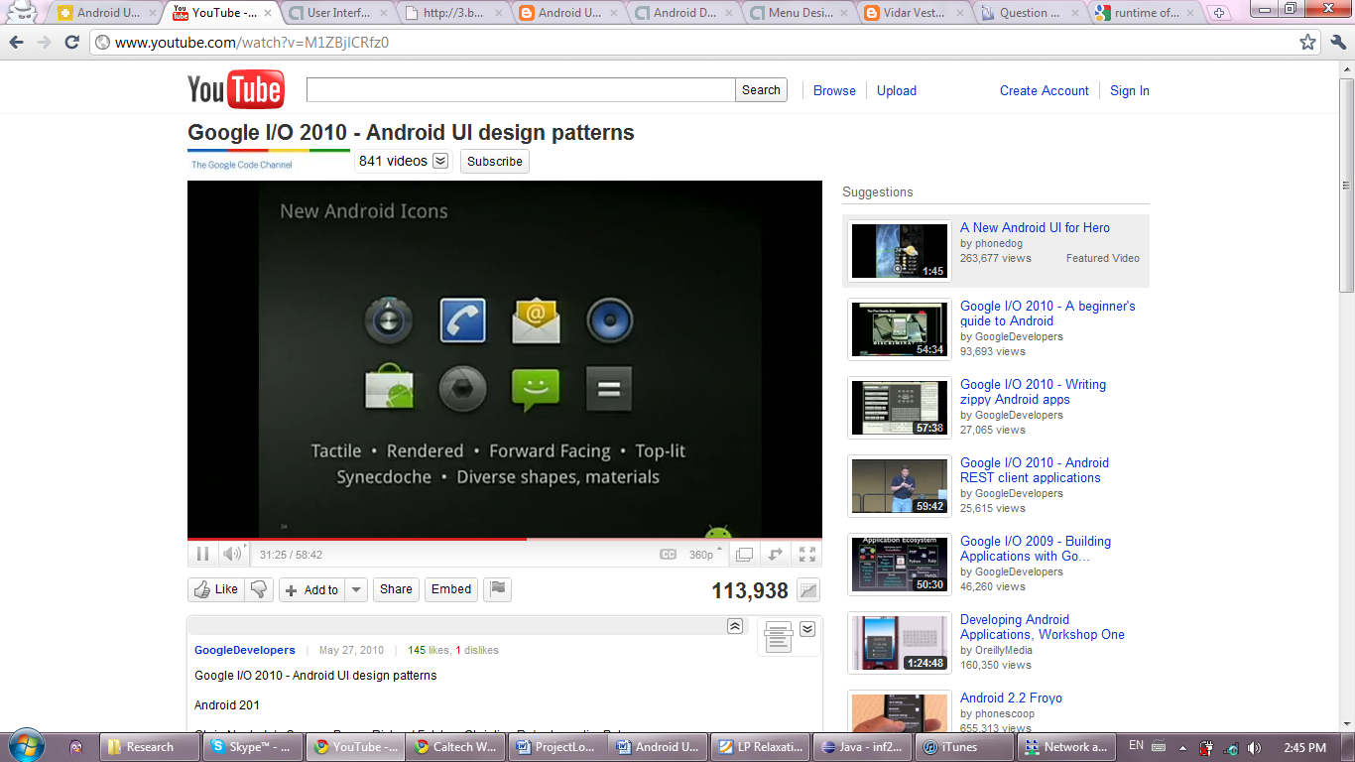

Icon Templates:

Available on the Dev guide

**Useful Resources:**

Google I/O 2010 – Android UI Design Patterns

<http://www.youtube.com/watch?v=M1ZBjlCRfz0>

Android Icon Templates <http://developer.android.com/guide/practices/ui_guidelines/icon_design.html>

<http://speckyboy.com/2010/05/10/android-app-developers-gui-kits-icons-fonts-and-tools/>

Different types of GUI

<http://vidarvestnes.blogspot.com/2010/01/android-gui-examples.html>